

Prepared by:

**Gerber Technology**

**YuniquePLM**

**Compliance Folder**

One of the main benefits of the YuniquePLM software application is to enhance collaborative working relationships for the purposes of product development. Very often this collaborative relationship involves compliance agreements or standardization. For this reason The Compliance Folder was developed as a point of reference for such documents and files. The compliance folder can be a general storage area for a variety of published documents such as testing procedures and requirements, or certificates of compliance and conformity.

To access the Compliance Folder click on the header located on the far right side of the desktop.

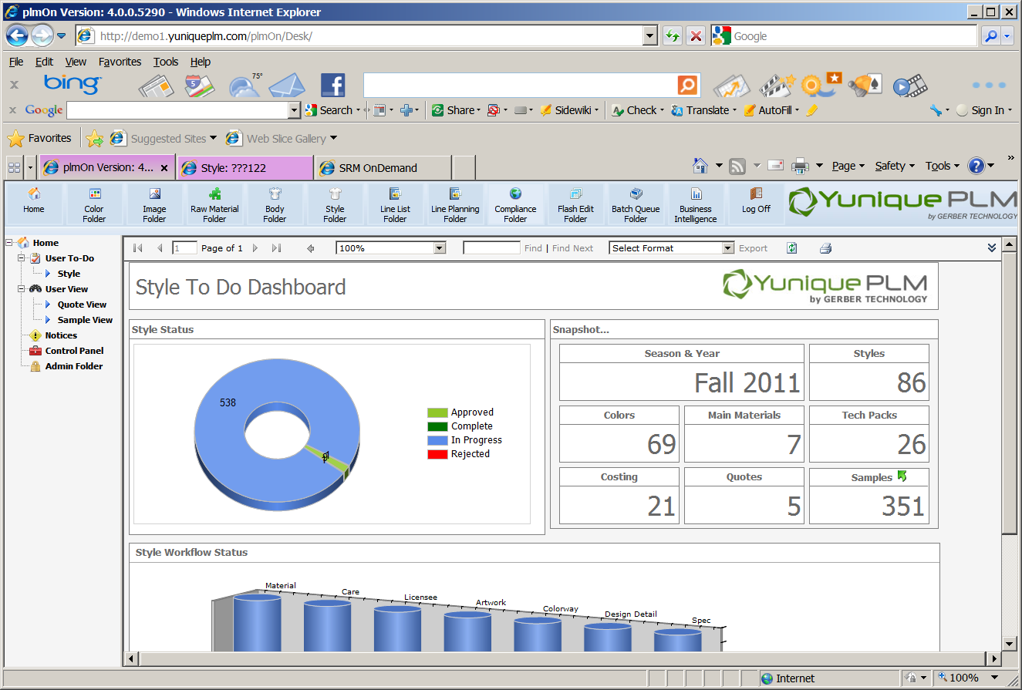

Once opened, there will be Resource a list on the left side of the window. Each of the resource labels listed will have a specific set of compliance documents for reference. The list of resources can be changed based on the business practices of an individual company.

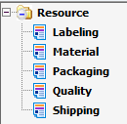

To view the documents within an individual resource folder, select the resource from the left side of the window. All of the documents available within the folder will be displayed on the right side of the window.

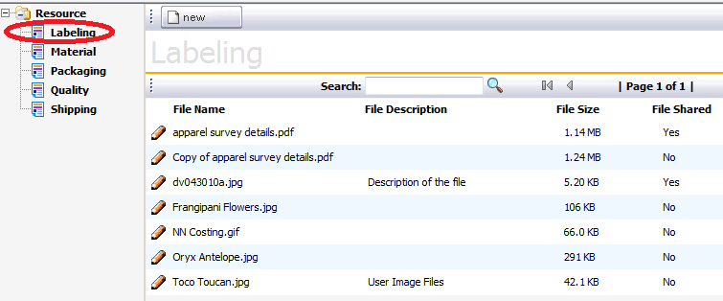

**Uploading New Documents**

Within each folder is a list of documents or files that relate to the resource selected. To upload a new document or file, click on the New button across the top of the window.



Next, click on the browse button presented on the right in order to select the desired file from a network location.

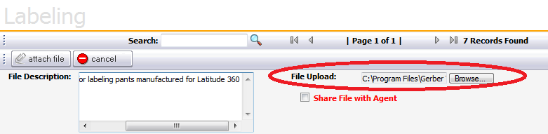

Once the file path is populated in the File Upload field an optional description of the file can be added to make browsing for the document easier. Also, a check mark can be added if Agents or Vendors outside of the main company entity will be able to view the document from the Yunique SRM software application. Once all additional information has been associated to the document, click on the Attach File button across the top of the window. Click the Cancel button to stop the process at any time.



**Viewing Published Documents**

To view or download a document from the compliance folder, click on the pencil icon on the far left of each file name listed.

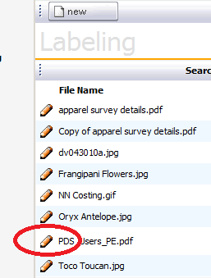

Once the file name has been expanded users can view the actual document/file by clicking on the Download button above the file name. The document can be deleted by YuniquePLM users with appropriate permissions to do so. Changes can be made to the file description, by typing directly in the field and then clicking the Save button above the file name.

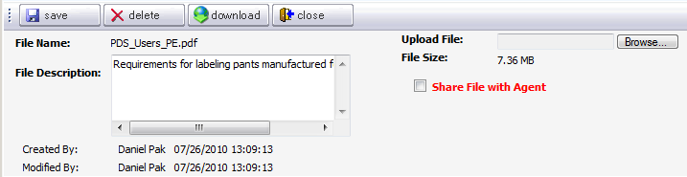

It is important to note that if there is a more current version of the file listed, then it will need to be uploaded again. Clicking the browse button and selecting a file from the network and then clicking Save, will replace the original document/file with the newer version. Click the Close button above the file name to return to the list view.